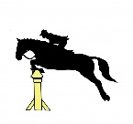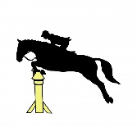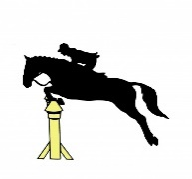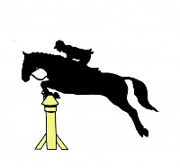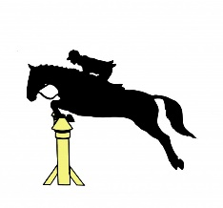
LOG FENCE PONY CLUB
SHOW JUMPING Spectacular
2019

The 2019 LFPC Show Jumping spectacular. The event will be open to PCAWA and Open/ Non-PCAWA members (18+ who have annual PCAWA Insurance). Each event will offer various heights, Ring 1 70cm – 105cm run as Am7. Ring 2 30cm - 60cm run as Optimum Time and Am7
Pre-enter closing date 23/07/19 Registration commences at 8.00am Jumping Commences at 9.00am Max of 3 rounds per horse You may enter in the same height non-competitive.
LFPC $10.00 per round Non-Member $12.00 per round
Insurance cards must be sighted along with Pony Club Cards Entries on the day will occur a $10 late fee Classes will be capped at 20 riders per class.
There is a $7.00 ground fee per horse on the day. Riders must supply helper on the day No Helper No Ride
PONY CLUB UNIFORM & NON-MEMBERS LONG SLEEVE SHIRT & TIE Ribbons placed to 6th Rug for high point pcawa and open, Any enquiries please phone Jamie Sherlock 0400241512. Log Fence Pony Club, its committee, judges, officials nor the PCAWA accept liability for any accident, damage, injury or illness to horses, ponies Riders, grooms, spectators, owner, helpers or any persons or property whatsoever. NO DOGS ALLOWED
We hope you have an enjoyable day and GOOD LUCK!!!

RING 1
RING 2

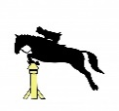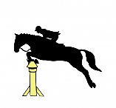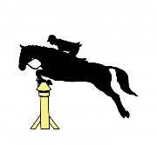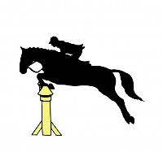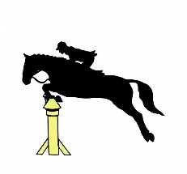
DATE OF EVENTS
28th July 2019

All riders to provide one helper per horse, limited self help available. If you require self- help we would prefer if you choose set-up/ pack away as your helper duty. If a person is named as a helper for more than one rider, more than one job will be given.
Competitors must have PCAWA insurance cover. Membership cards or proof of Insurance must be shown before riding. All riders must present to office before riding.
Open riders (18+ only) are able to purchase annual PCAWA insurance from $40 online from the PCAWA website.
Riders under 18 years must be a member of a Pony Club to be insured and able to compete.
Horse /Rider combinations may compete in both arenas, as long as a maximum of three consecutive height rounds are jumped per event. If a rider chooses to compete in both arenas, they may be required to jump their higher height rounds first. There will be non-competitive rounds available time permitting.
Riders must wear long sleeve shirts (open competitors) or Pony Club uniform (PCAWA classes).
All riders must be gear checked before competing. PCAWA gear checking rules will apply for all classes and competitors are responsible for being aware of these rules.
Competitors must notify the organisers of withdrawal prior to close of entries to obtain a refund minus $5 book keeping fee. After this date, a refund will only be given if a Vet or Doctors certificate is received by the organiser within 2 weeks of the event. A $10 book keeping fee will apply.

Organisers reserve the right to amend/ join classes as required and have the absolute discretion to refuse entry to, or eject any competitor from any class, event or series for any reason.
Organisers reserve the right to reschedule any event Organisers reserve the right to determine and amend prizes (including rugs) for each and any class, event or the series according to the level of entries or any other reason.
Points are allocated based on horse/rider combination. Combinations can only compete at 3 consecutive heights .
placegetters will be announced at the event ending 28th july 2019

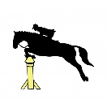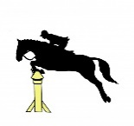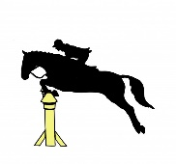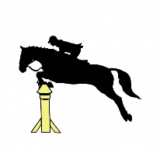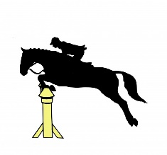
Ring 1 Ring 2
70cm Am7 PCAWA 30cm Opt Time PCAWA
70cm Am7 Open 30cm Opt Time Open
80cmAm7 PCAWA 40cm Opt Time PCAWA
80cm Am7 Open 40cm Opt Time Open
90cm Am7 PCAWA 50cm Am7 PCAWA
90cm Am7 Open 50cm Am7 Open
105cm Am7 PCAWA 60cm Am7 PCAWA
105cm Am7 Open 60cm Am7 Open

Description of Events
OPTIMUM TIME - the rider endeavours to ride the course according to how the judge has measured the course and worked out which speed it should be ridden at. The rider closest to the time with the least number of Faults are the winner. AM7 – A competitor with a clear round rides a jump off course before leaving the arena. The competitor has 45 Seconds only to go through the starting flags after the judge sounds the bell for the jump-off. The AM7 jump-off May include two new obstacles

Log Fence Pony Club 2018 Show Jumping Day ENTRY FORM
ONE RIDER/HORSE COMBINATION PER ENTRY FORM ONLY
NAME: ______________________________________________ AGE: _________
PH: _____________________ EMAIL ADDRESS:_____________________
ADDRESS:__________________________________
HORSE / PONY NAME:_________________________________ AGE: ____
HELPER’S NAME: ______________________ HELPER’S PH: _______________
PREFFERED HELPER JOB:
Penciller: Ring1: ____Ring2: _____ Gate Marshal Ring1: _____Ring2: __________
Gear Checker Ring 1: ____Ring2: _____ Pack up: _____ Arena Party: _______ Canteen: ________
Toilets: _____ Helper Jobs will be a max of 1.5hrs Please enter 1st and 2nd preference; we will endeavour to meet your preferences
Email & POST ONLY
Post Entries: Jamie Sherlock 102 Thornton Road Uduc 6220
Email Entries: Jamie Sherlock @ bessrex@hotmail.com
Please make cheques payable to Log Fence Pony Club
Direct Debt Log Fence pony club bsb:036152 acc:210773
Reference first initial and surname
RING | NAME OF CLASS | Fees Paid
 | Ground Fee Per Horse/Pony | $7.00
 | Enter on the Day Late fee $10 | $
 | Total Fees Payable | $

