Commonwealth Clydesdale Horse Society WA Branch
in association with the Shire of Serpentine Jarrahdale

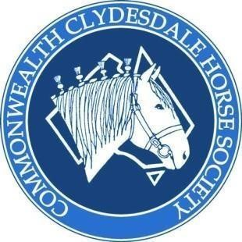

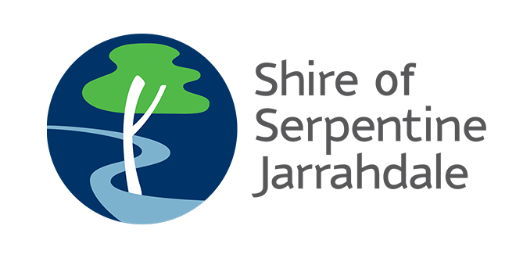

Proudly presents

CCHSWA HEAVY HORSE EXTRAVAGANZA 2021
OCTOBER 16 & 17, 2021
AT MuNdijong markets

Judges will be confirmed closer to show date
given covid restriction changes
H
We reserve the right to make alterations to the program as necessary. ALL horses to be under control AT ALL TIMES.

DOGS – SORRY NO DOGS PLEASE. YOU WILL BE ASKED TO LEAVE

No unruly behaviour will be tolerated! Leave your personal issues at the gate, just come along and have some fun and enjoy your horses.

If entries are low in certain breeds we may have to combine classes! So encourage people you know with heavy horses to please attend.

Halter Information
Stallions and Colts must have suitable and substantial headgear with bit, as per breed standard. The age of the handler must be 18 years of age or over. All horses that enter the led classes must be registered with the relevant breed society. Please provide a copy of the registration papers with your entry.

Ridden
All riders must wear approved safety helmets.

Harness Information
Please bring with you your chains or leather traces of minimum length 2340mm (2.34 m). Also check that your hooks can fit over 10 mm steel. No carabineers or closable clips allowed, you MUST use hooks. ALL horses must be bitted.

Novice refers to handler who has not won a class at a harness show.

Open refers to a handler that has won a novice, intermediate or open class.

Maiden refers to horse that has never won a class at a harness show.

The Harness classes are open to registered & unregistered heavy horses.

Protests
Formal written & signed Protests to be submitted within 30 minutes from the conclusion of the event, with a $50.00 fee (non-refundable). Ground Jury decision will be final and cannot be protested.
The Judge's decision is FINAL.

Points will only be collated from selected classes. If people compete in Beginner, Novice and Open then the highest winning points will be taken from only 1 class.

Camping
Gate will be open from 12:00 pm on Friday.

Please clean out your stalls before you leave.
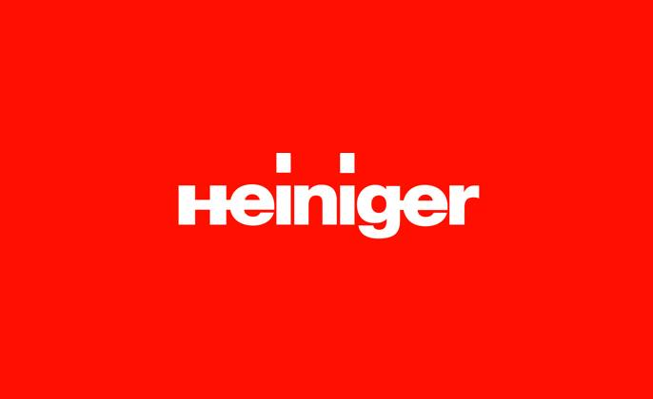

Saturday October 16 Ring 1 - Halter Classes 9am Start

GYPSY COB  - Best Presented Gypsy Cob  - Best WA Bred  - Best Non WA bred  - Gypsy Cob Mare/Filly any age  - Champion & Reserve Mare/Filly  - Gypsy Cob Colt/Stallion any age  - Champion & Reserve Colt/Stallion  - Gypsy Cob Gelding any age  - Champion & Reserve Gelding  - SUPREME GYPSY COB | DRUM HORSE  - Best Presented Drum Horse  - Best WA Bred  - BEST Non WA bred  - Mare/Filly any age  - Champion & Reserve Mare/Filly  - Colt/Stallion any age  - Champion & Reserve Colt/Stallion  - Gelding any age  - Champion & Reserve Gelding  - SUPREME DRUM | PART BRED GYPSY COB  - Best Presented Part Bred Heavy Horse  - Mare/Filly any age  - Champion & Reserve Mare/Filly  - Colt/Stallion any age  - Champion & Reserve Colt/Stallion  - Gelding any age  - Champion & Reserve Gelding  - PART BRED HEAVY HORSE
SHIRE  - Best Presented Shire  - Best WA bred  - Best non WA bred  - Mare / filly any age  - Champion & Reserve Mare/Filly  - Colt 3 years & under  - Stallion 4 years & over  - Champion & Reserve Colt/Stallion  - Gelding 3 years & under  - Gelding 4 years & over  - Champion & Reserve Gelding  - SUPREME SHIRE | PART BRED CLYDESDALE (CCHSWA Registered)  - Best presented Part Bred Clydesdale  - Filly 3 years & under  - Mare 4 years & over  - Champion & Reserve Mare/Filly  - Colt/ Stallion any age  - Champion & Reserve Colt/Stallion  - Gelding 3 years & under  - Gelding 4 years & over  - Champion & Reserve Gelding  - SUPREME PART BRED CLYDESDALE | 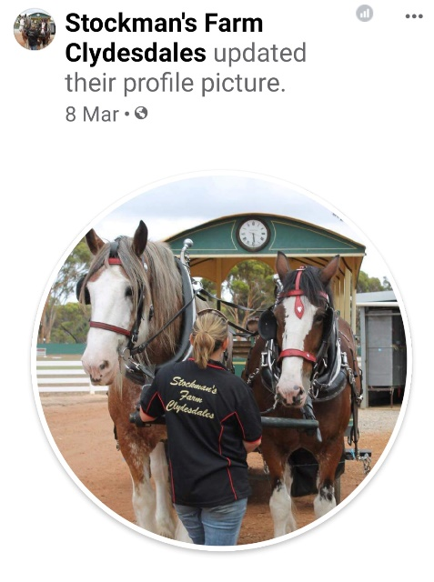
CLYDESDALE  - Best Presented Clydesdale  - Best WA bred  - Best Non WA bred  - Filly 3 years & under  - Mare 4 years & over  - Champion & Reserve Mare/Filly  - Colt 3 years & under  - Stallion 4 years & over  - Champion & Reserve Colt/Stallion  - Gelding 3 years & under  - Gelding 4 years & over  - Champion & Reserve Gelding  - SUPREME CLYDESDALE | CLYDESDALE SPORTHORSE (CCHSWA Registered)  - Best Presented Clydesdale Sport horse  - Filly 3 years & under  - Mare 4 years & over  - Champion & Reserve Mare/Filly  - Colt/ Stallion any age  - Champion & Reserve Colt/Stallion  - Gelding 3 years & under  - Gelding 4 years & over  - Champion & Reserve Gelding  - SUPREME CLYDESDALE SPORTHORSE

Saturday October 16 Ring 2 - Halter Classes 9am Start

FRIESIAN WARMBLOOD  - Best Presented Friesian Warmblood  - Filly 3 years & under  - Mare 4 years & over  - Champion & Reserve Mare/Filly  - Colt/Stallion any age  - Champion & Reserve Colt/Stallion  - Gelding 3 years & under  - Gelding 4 years & over  - Champion & Reserve Gelding  - SUPREME FRIESIAN WARMBLOOD | WALERS  - Best Presented Waler  - Mare/Filly any age  - Champion & Reserve Mare/Filly  - Colt/Stallion any age  - Champion & Reserve Colt/Stallion  - Gelding any age  - Champion & Reserve Gelding  - SUPREME WALER | ANY OTHER REGISTERED HEAVY HORSE  - Best Presented Any Other Heavy Horse  - Horse Filly/Mare any age  - Champion & Reserve Mare/Filly  - Colt/Stallion any age  - Champion & Reserve Colt/Stallion  - Gelding any age  - Champion & Reserve Gelding  - SUPREME ANY OTHER REGISTERED HEAVY HORSE
HIGHLAND PONY  - Best Presented Highland Pony  - Mare/Filly any age  - Champion & Reserve Mare/Filly  - Colt/Stallion any age  - Champion & Reserve Colt/Stallion  - Gelding any age  - Champion & Reserve Gelding  - SUPREME HIGHLAND PONY | PERCHERON  - Best Presented Percheron  - Mare/Filly any age  - Champion & Reserve Mare/Filly  - Colt/Stallion any age  - Champion & Reserve Colt/Stallion  - Gelding any age  - Champion & Reserve Gelding  - SUPREME PERCHERON | 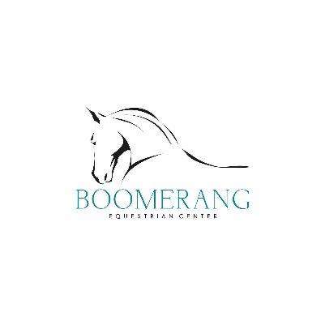
CLEVELAND BAY  - Best Presented Cleveland Bay  - Mare/Filly any age  - Champion & Reserve Mare/Filly  - Colt/Stallion any age  - Champion & Reserve Colt/Stallion  - Gelding any age  - Champion & Reserve Gelding  - SUPREME CLEVELAND BAY | ANY UNREGISTERED HEAVY HORSE  - Best Presented Any Other Heavy Horse  - Horse Filly/Mare any age  - Champion & Reserve Mare/Filly  - Colt/Stallion any age  - Champion & Reserve Colt/Stallion  - Gelding any age  - Champion & Reserve Gelding  - SUPREME ANY UNREGISTERED HEAVY HORSE

The following are to be judged by both judges

SUPREME JUNIOR OF THE SHOW
ALL HORSES 3 YRS AND UNDER ELIGIBLE
Supreme Junior will win a rug and a sash

TOP 3 OF THE DAY AND SUPREME OF SUPREME ALL SUPREME WINNERS ELIGIBLE pick 4 horses, top 3 and supreme of supreme
Supreme of Supreme to win a rug and a Sash

30 minute break, ready for Ridden

Ridden Classes – Judged by both Judges
- Lead Line | 4. ANY OTHER HEAVY HORSE  - Ridden Mare  - Ridden Gelding  - Ridden Stallion  - SUPREME RIDDEN HEAVY HORSE | 7. FANCY DRESS  CAN BE RIDDEN OR LED
- JUNIOR 17 YRS AND UNDER  - Novice Ridden  - Open Ridden  - SUPREME JUNIOR | - PART BRED HEAVY HORSE  - Ridden Mare  - Ridden Gelding  - Ridden Stallion  - SUPREME RIDDEN PART BRED
- CLYDESDALE  - Ridden Mare  - Ridden Gelding  - Ridden Stallion  - SUPREME RIDDEN CLYDESDALE | - RIDDEN OBSTACLE  Trail Type (Anything from opening gates, obstacles, picking up and putting down objects, water, tarps)  This will be decided on the day.

Sunday October 17 Harness Classes 9:30am Start - To be judged by both Judges

JUNIOR DRIVER  Under 18 years old. Horse must be driven in long reins | YOUNG HORSE OBSTACLE  Horse is to be led on the ground. This will be a timed event .  Points will be deducted for any obstacle not achieved.  3 attempts at each item only. Horse under 3 years | TEAM EVENT  Teams must have 3 team members in order to compete in this class.  Please register your full team if you can, otherwise we will pair up as we can.  This is a team-based event consisting of a long rein course, a log snig course and a sled course. 1 horse for each.  Timed and accuracy
BEGINNER DRIVER  Driver never won a novice event at a working show; horse must be driven in long reins | JUNIOR DRIVER OBSTACLE  Must be driven in long lines, timed event.  The obstacle course will be set up on the day.  Judged on each obstacle and timed event.  Max 3 attempts at each task | SINGLE HORSE WHEELED CLASS  Single horse in a wheeled vehicle  Single wheeled and 4 wheels  Judged Separately
OPEN DRIVER  Horse must be driven in long reins.  Cannot compete in beginner | OBSTACLE DRIVEN  Must be driven in long lines, timed event.  The obstacle course will be set up on the day.  Judged on each obstacle and is a timed event. | PAIRED WHEELED CLASS  Pairs in a wheeled vehicle
MAIDEN HORSE  Horse has never won a first place at a working show. Horse must be driven in long reins | LOG SNIG  Horse must be driven in long lines.  Drivers are not allowed to adjust, alter, assist the horse by moving harness or chains, once the course is started until horse and driver have finished the course. | 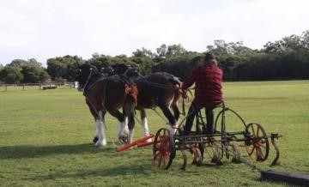
OPEN HORSE  Horse must be driven in long reins.  Cannot compete in maiden as well | SLED OBSTACLE  Collect the tennis balls going up and bend back through the cones coming back. Penalties apply for dropped balls and knocked cones.

CCHS MEMBER’S INDEMNITY FORM

PLEASE PRINT ALL DETAILS
CCHS BRANCH:
EVENT TITLE:
NAME OF MEMBER IN CCHS EVENT:
ADDRESS:

CONTACT TELEPHONE NO:

EMAIL ADDRESS:

I agree and consent to being a participant in the above outlined event. I hereby also agree to release, discharge and to hold the Commonwealth Clydesdale Horse Society harmless for any accidents, harm and/or loss, which I may suffer as a result of participating in the outlined event.

In addition, I hereby agree to indemnify the Commonwealth Clydesdale Horse Society and its servants, volunteers and agents for any loss, demands, damages, expenses, claims, actions and suits brought for and on behalf of myself and arising out of or in any way connected to the outlined event.

I authorise the Commonwealth Clydesdale Horse Society to obtain any medical or hospital treatment as in its opinion may be required for myself. I agree that this indemnity shall extend to the decision of the Commonwealth Clydesdale Horse Society to obtain or administer such medical treatment and I further agree to pay the costs of such treatment.

In the event of there being any known medical conditions for myself or the need to taking of medication which would affect the rendering of any urgent medical assistance, I give consent that my details be recorded below and kept in a confidential manner by the above named group organising this event.
Known Allergies:

Medication:

Signature: ____________________________________________________ Date: _____________

PRIVACY DISCLOSURE STATEMENT

The Commonwealth Clydesdale Horse Society (CCHS) collects your personal information in order to administer the Clydesdale Show and for related purposes, such as promoting the event, or making claims on any insurance in connection with the event. Your information may be disclosed to service providers and other organisations who help to administer the show (Including medical practitioner St John Ambulance Officers and other health service providers) indemnity or insurance providers, other Commonwealth Clydesdale Horse Society branches, or organisations that have similar objects to the CCHS including breed associations recognised by the CCHS. Your information may also be disclosed if required or authorised by law.

We may also publish winners’ details on our websites or publications, or we may disclose information about you to the media for the purpose of publishing articles on your participation in the Show.

Tick this box if you do not want your information published or disclosed for these purposes.

We may also use your information to advise you about other CCHS events and services (such as further events) by post.

Tick this box if you do not want us to send you information by post.

You have certain rights to access personal information that we hold about you. To find out about this or if you have any other queries about our privacy practices, please write to: The Secretary, CCHS Federal Council Inc., R.G. Bowles Pty Ltd, P.O. Box 1053, BENDIGO VIC 3552 or phone: (03) 5442 8890.
CONDITIONS OF ENTRY
I have read the Privacy Disclosure Statement and have agreed to the statement as presented.
Signature: ____________________________________ Date: ____________________
(Parent or Guardian must sign if Exhibitor is under 18 years)
Please note that we are unable to accept your entry form unless it has been signed.

INSURANCE
The CCHS has negotiated Public Liability Insurance for the coming year to accommodate the needs of the Members. Casual Day insurance is an option for non-Members to attend events, but it has increased to $20 for each event and is only available to people that have not been previous Members. Once you pay your Membership you are covered under the CCHS Public Liability insurance cover. The Insurance covers Members at all CCHS events, meetings, or field days, and training day activities.

The Commonwealth Clydesdale Horse Society
Federal Council Inc.
Reg. No. A0019631A ABN 24 748 123 650

PO Box 1053 Bendigo Victoria 3552
Telephone: (03) 5442 8890 Facsimile: (03) 5442 5264

APPLICATION FOR
CASUAL DAY PARTICIPANT INSURANCE

NAME: ....................................................................................................................................
ADDRESS: …..............................................................................................................................
POSTCODE: .......................................... TELEPHONE: ......................................................

EMAIL: .................................................. FAX: ......................................................................
CCHS BRANCH: ......................................................................................................................
EVENT: ....................................................................................................................................
I wish to compete in event conducted by this Society and/or a Branch of this Society and agree to pay the Casual Day Participant Insurance Levy. I understand that payment of this levy is required for insurance purposes and does not entitle me to membership of the Society. I am aware that after using this insurance levy twice within a financial year, I may be offered full membership by completing a CCHS membership application and pay the prescribed fee of $60.00 per annum to the Society, and that the annual Membership levy falls due on 1st July of each year.

I agree to abide by all decisions of the Society in relation to all matters arising out of or in connection with each event in which I participate.

Enclosed please find remittance of $20.00 per event being for Casual Day Participant Insurance.

I _________________________ as the participant accept the above agreement.

Signature:.......................................................... Printed Name: ...........................................

Date: ..................................................................

Note: $20.00 Fee includes GST

CCHS JUNIOR COMPETITORS INDEMNITY FORM

APPICABLE FOR PERSONS:
- UNDER 18 YEARS OF AGE &
- WHO HAVE PAID THE JUNIOR COMPETITORS LEVY PLEASE PRINT ALL DETAILS

ATTENTION PARENTS/LEGAL GUARDIANS

In order to ensure that your child/ward can participate in the CCHS event and appropriate care is taken for your child/ward, it is essential that you read and sign the following.
CCHS BRANCH:

EVENT TITLE:

Name of Junior Participant in CCHS Event:

Date of Birth:

Name of Parent/Legal Guardian:

Address:

Contact Telephone No: Relationship:

I agree and consent to my child/ward to participate in the above detailed Commonwealth Clydesdale Horse
Society Event. I hereby also agree to release, discharge and to hold the Commonwealth Clydesdale Horse Society harmless for any accidents, harm and / or loss which my child/ward may suffer or that I may suffer as a result of my child/ward participating in the outlined event.

In addition, I hereby agree to indemnify the Commonwealth Clydesdale Horse Society and its servants, volunteers and agents for any loss, demands, expenses, claims, actions and suits brought for and on behalf of my child/ward and arising out of or in any way connected to the outlined event.

I authorise the Commonwealth Clydesdale Horse Society to obtain any medical or hospital treatment as in its opinion may be required for myself. I agree that this indemnity shall extend to the decision of the
Commonwealth Clydesdale Horse Society to obtain or administer such medical treatment and I further agree to pay the costs of such treatment.

In the event of there being any known medical conditions for my cold/ward or the need for taking of medication which would affect the rendering of any urgent medical assistance, I give consent that my details be recorded below and kept in a confidential manner by the above named group organising this event.
Known Allergies:
Medication:
Signature: Date:

(Parent/Legal Guardian):o Date:

ENTRY FORM
Entries close 13 October 2021 (no entries on the day)

Members $10 a class
Second horse with same owner $8
Non members $12 a class
Second horse non member $10 a class

Name:

Address:

Phone:

Email:

Class No | Breed | Class Name | Horse’s Name | Handler’s Name | Fees
 |  |  |  | Subtotal | $
 |  |  |  | Insurance Non Members $20 (Covers both days) | $
 |  |  |  | Ground Fee Per Day ($10/day) | $ 10
 |  |  |  | TOTAL | $

PAYMENT DETAILS – Direct Deposit

Account Name: CCHSWA BSB: 066 157 Account Number: 0090 7492

Email: tamwa@bigpond.com Phone: Susan 0414879854

Please include the following:
- Signed form (applicable to members and non-members)
- Registration papers
- Payment receipt

