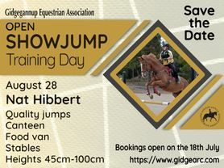

Bookings & Details : https://www.gidgearc.com/showjump-training-day
Cost: $14/round
Ground Fee: $10 ( GEA, GH&PC, GDC EXEMPT)
Competition/Day Membership: $15 (GEA & EWA members exempt)
Heights: 45cm, 65cm, 80cm, 90cm, 100cm

A maximum of 3 classes at 2 consecutive heights can be entered per horse and rider combination.

One entry form per horse/rider combination
First class starts at 8:30-9:00am depending on numbers

PARTICIPANTS MUST COMPLETE THE FOLLOWING FORMS
(GEA & EWA MEMBERS EXEMPT)

Waiver: https://www.gidgearc.com/sjtd-waiver-form
Competition/DayMembership Application: https://www.gidgearc.com/compday-mship-form

